**Project:** **Messaging App**

10/12/2024

**Name:** Hasham Aziz **Roll Number:** SP24-BSE-041 ( Section – B )

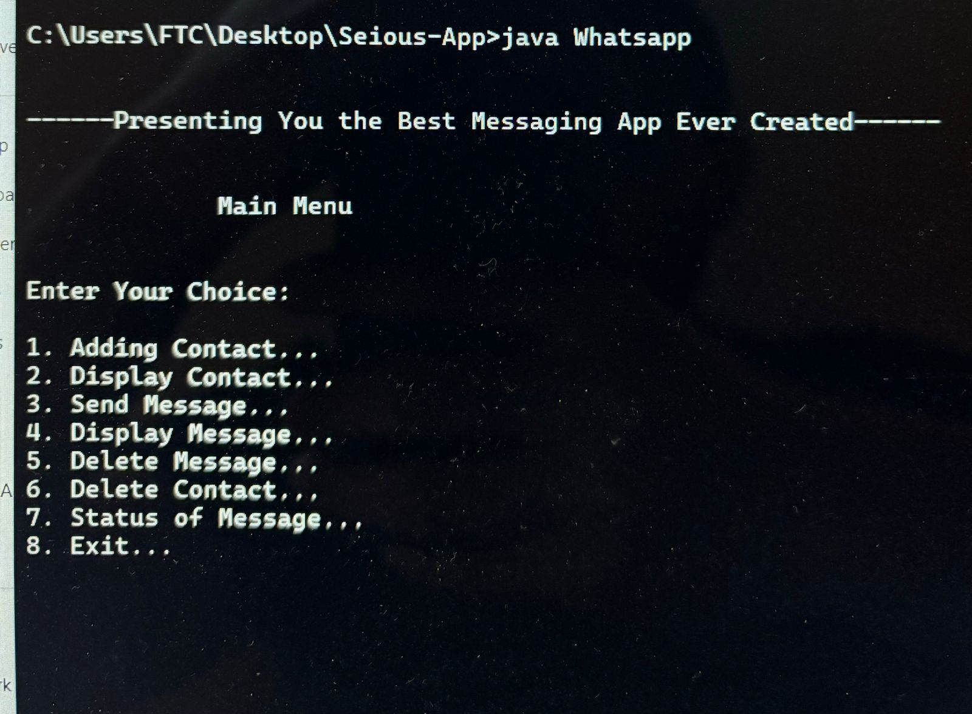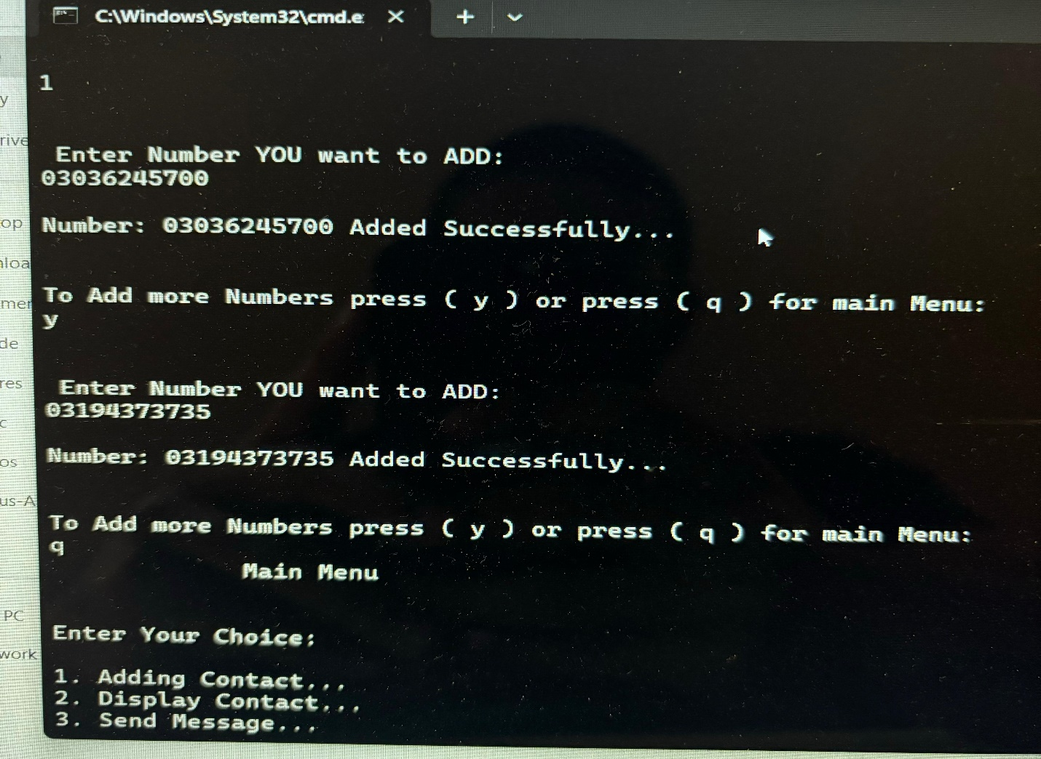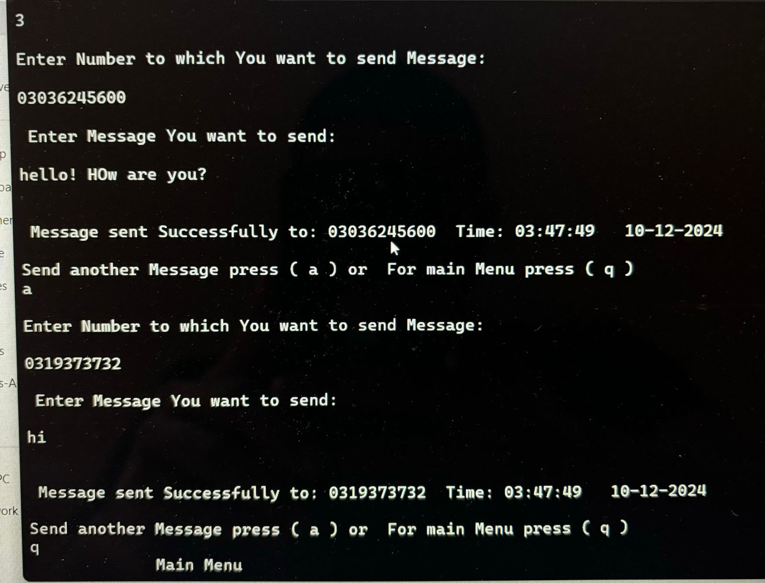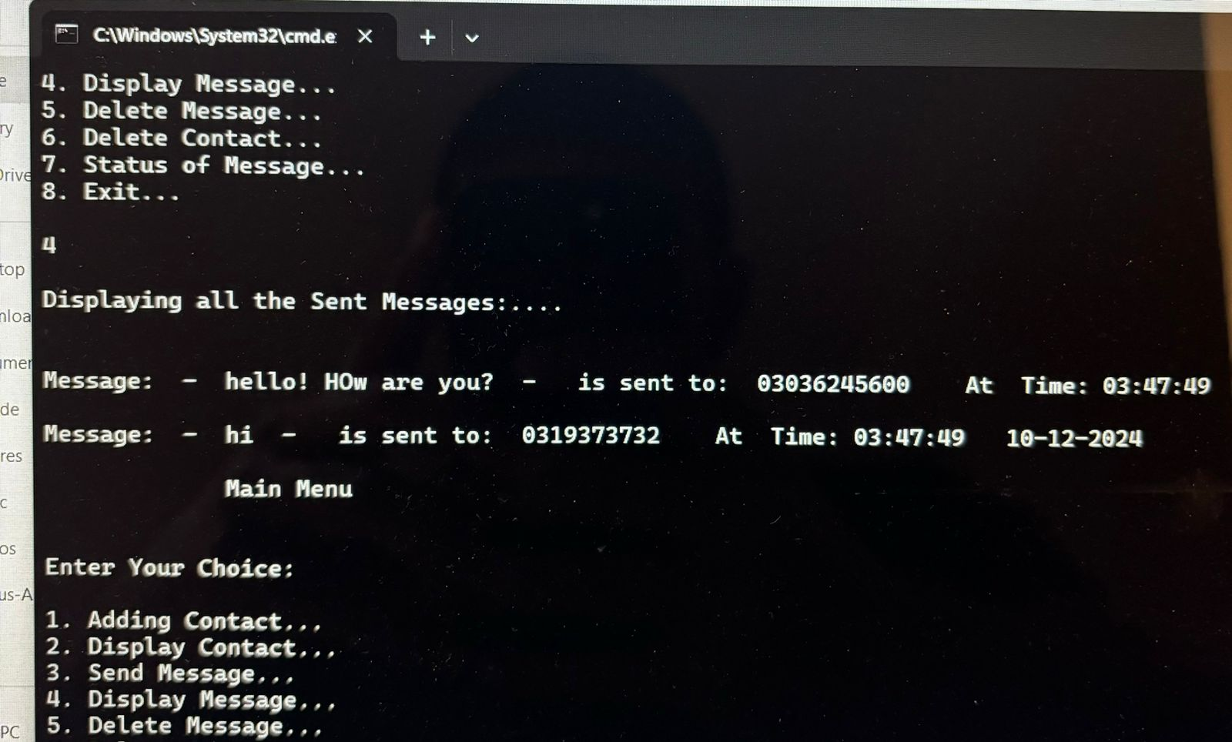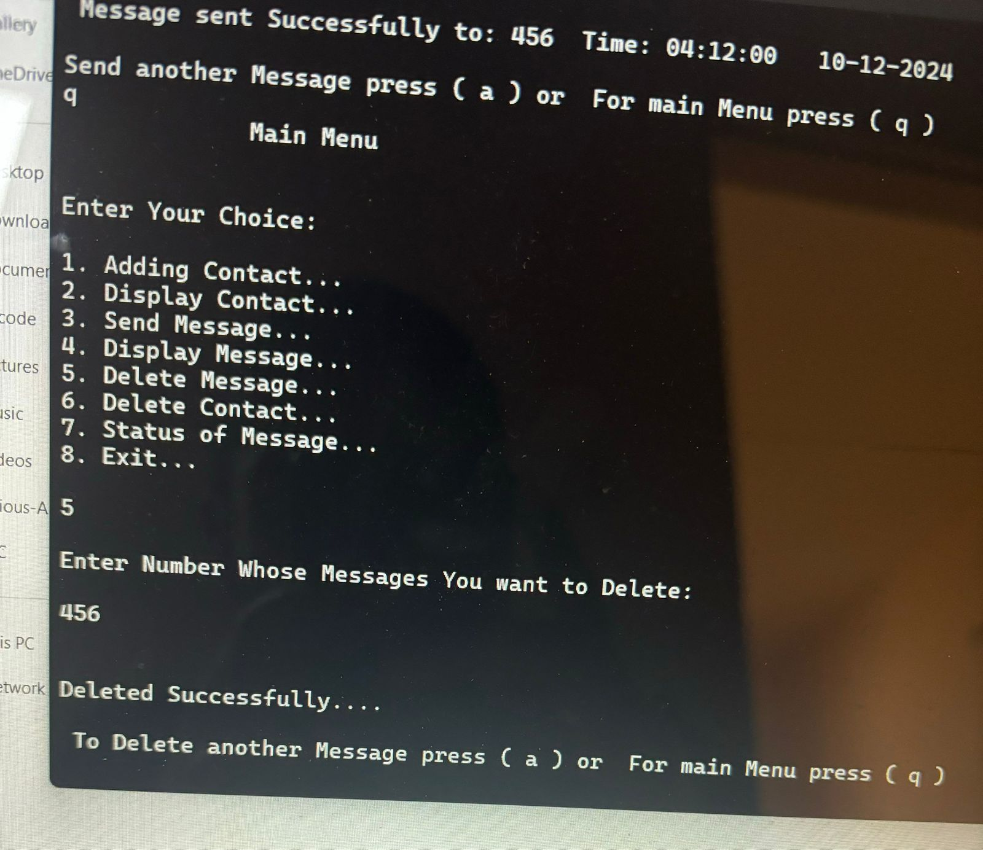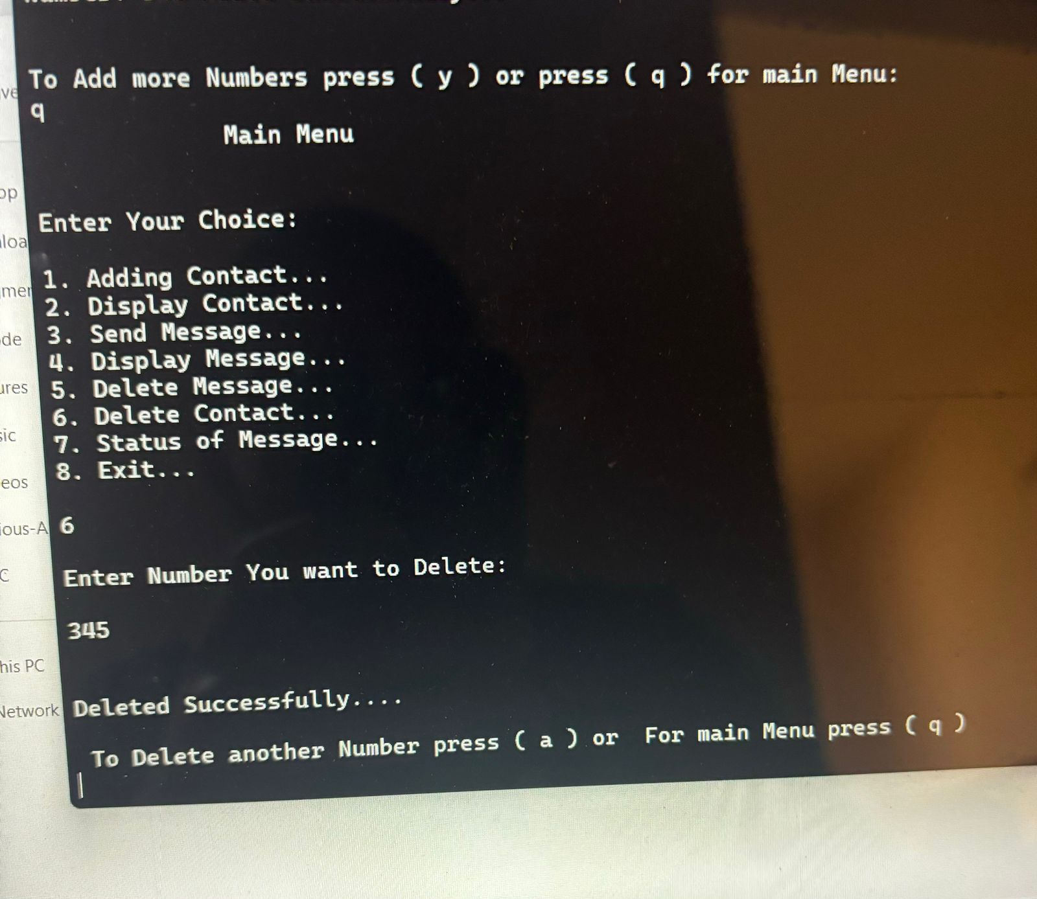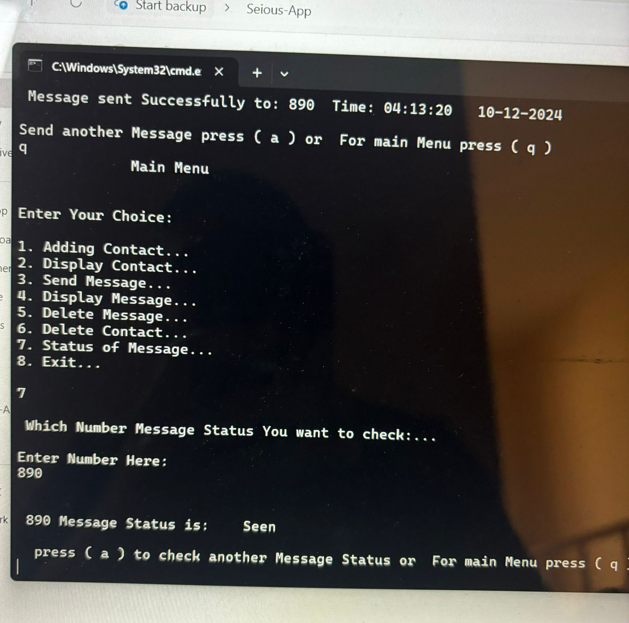

Assigment OOPs

**Submitted to:** *Sir Shahid Bhatti*

**Main console**

**Adding contact function**

**Message sending function**

**Displaying sent messages**

**Delete message**

**Delete Contact**

**Status of message**